The Upgrade Steps by PC for N5MAX
- Pls prepare those device for upgrade as below:
1 * Computer
1 * USB cable
1*Small iron needle (diameter can not be greater than 4CM)
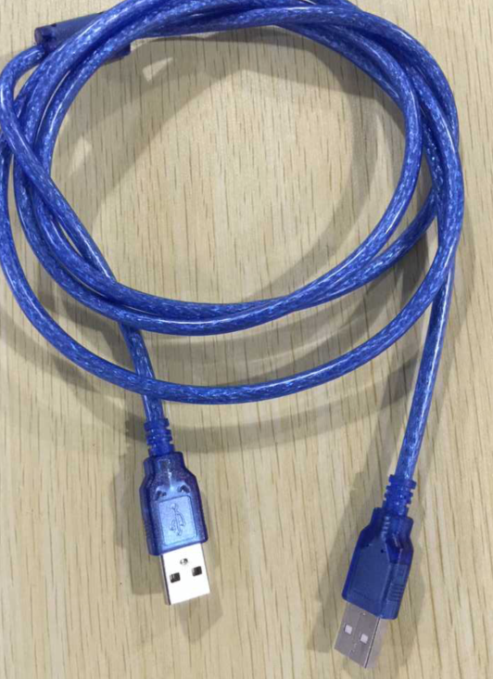
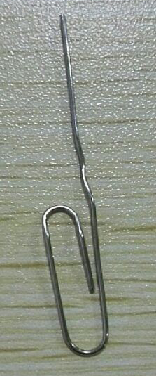

- Install USB_Burning_Tool_setup_V3.2.0.exe tools as below, after the installation is complete, there is a shortcut icon in the desktop,
- Double-click the icon to open the upgrade tools
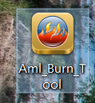

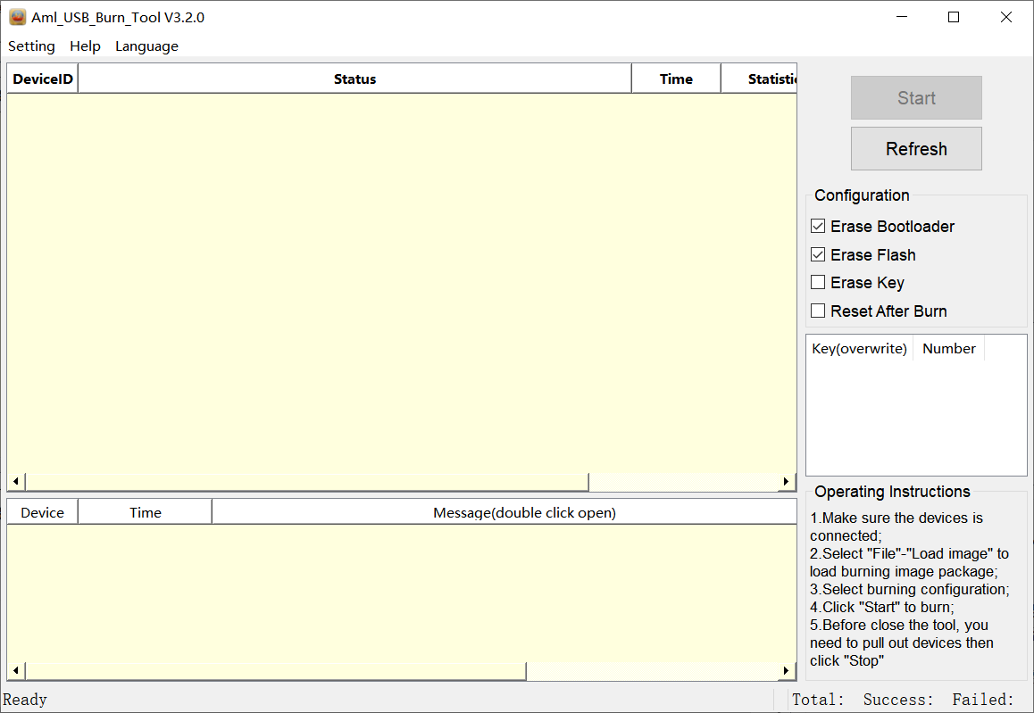

4. Connect the USB port on PC by USB cable
With a small iron needle from the AV hole and holding, then plug the USB cable to the motherboard on the OTG Port (the box's USB port).
Wait until the corresponding port on the tool shows "Connection is successful", then you can remove the small Iron needle from AV port.
(If there is no prompt for connection, please try again)
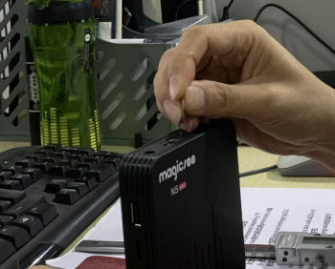
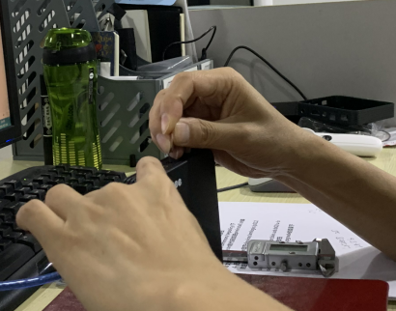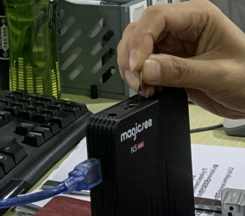
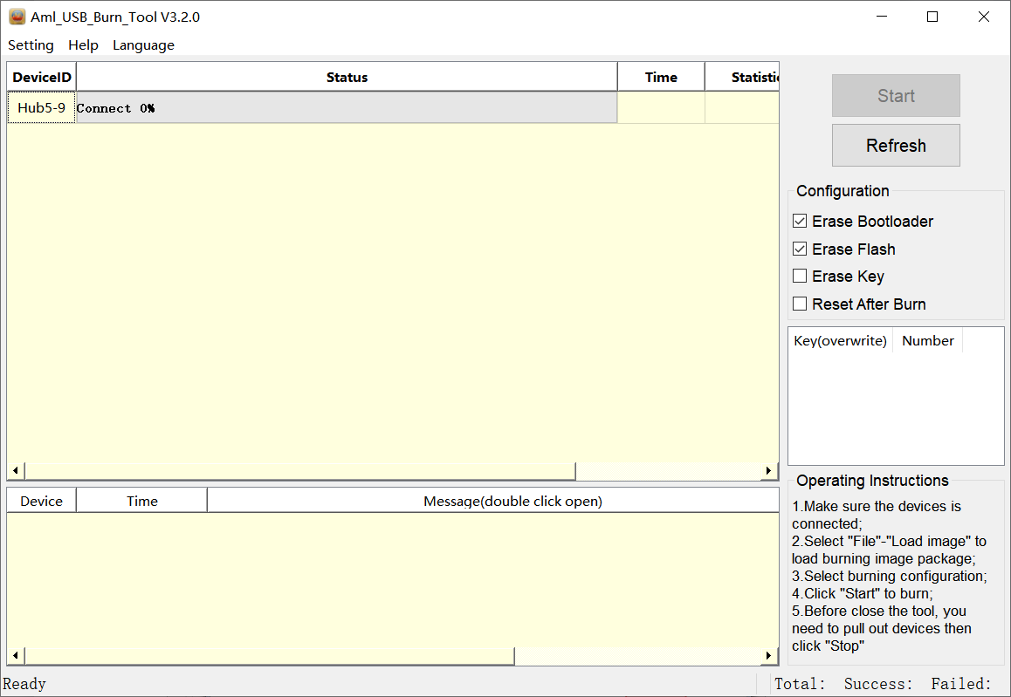

5. Open the “.img File”, then pls go to choose the firmware from your PC .
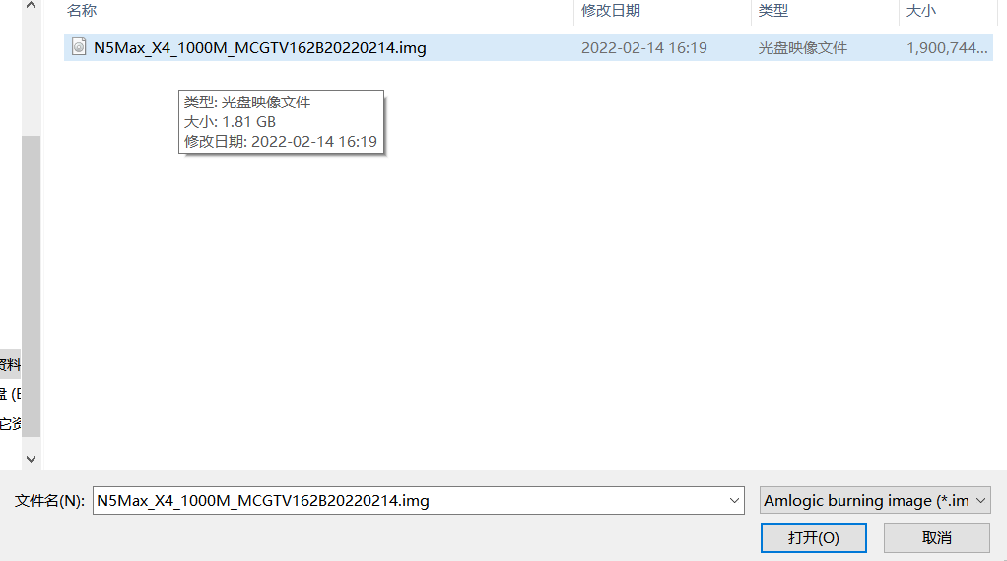
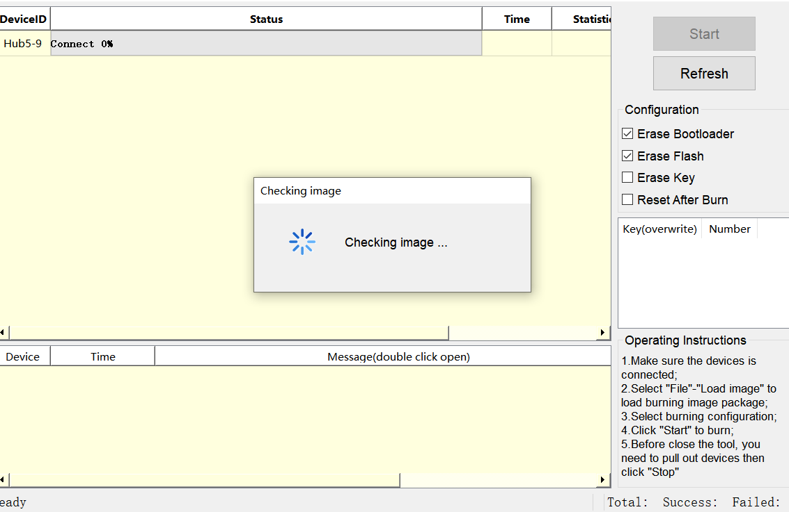
6. Press “Start” after Setting as blow:
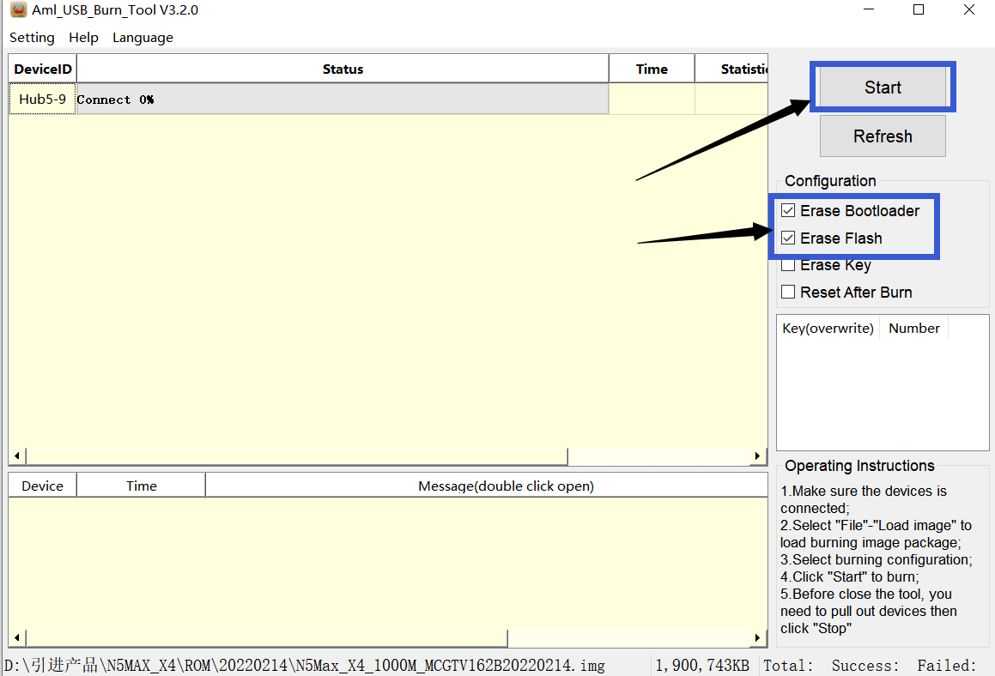
7. when the bar going to 100%, it means successfully.
8. Boot up your Box
& Enjoying the new!

